Sample Abstract for AWTEC 2018
First Author^{#1}, Second Author^{*2}, Third Author^{#3}
#First-Third Department, First-Third University
Address Including Country Name
¹first.author@first-third.ac.uk
³third.author@first-third.edu
*Second Company
Address Including Country Name
²second.author@second.com

- Keywords
Include five keywords describing the content of the work to be presented.
- Abstract
The aim of this one page abstract is to describe as compactly as possible the content of the work to be presented later in a full paper.
This abstract will be submitted to a first reviewer panel, in order to check the validity of the proposal in terms of:
- compliance of the work with the global scientific and technical perimeter of the AWTEC Conference defined by the ten thematic tracks (www.awtec.asia/awtec-2018/thematic-topics/),
- the paper has a real technical interest, and is not simply a commercial advertisement for a product or service,

Besides the textual presentation of their work, authors may present in the abstract samples of their results as photographs, figures, graph, tables, etc…, all forms which can help the reviewer to appreciate the interest of their paper.

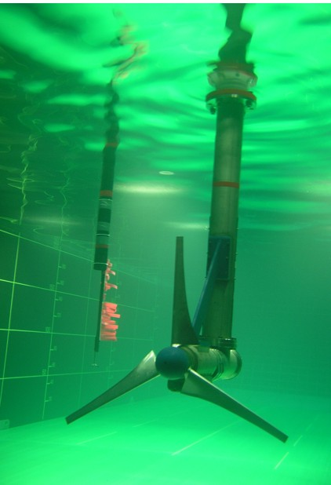
Fig. 1 Example of an image with acceptable resolution

Bibliographic references may also be used in the abstract as they can help the reviewer to place the presented work in its proper context in its relation to previous published studies.

In that case, author should conform to the reference style as illustrated by the list given below as an example. (see the AWTEC full paper template for details).
Fig. 1 A sample plot using colours which contrast well both on screen and on a black-and-white hardcopy

References
- S. M. Metev and V. P. Veiko, Laser Assisted Microtechnology, 2nd ed., R. M. Osgood, Jr., Ed. Berlin, Germany: Springer-Verlag, 1998.
- J. Breckling, Ed., The Analysis of Directional Time Series: Applications to Wind Speed and Direction, ser. Lecture Notes in Statistics. Berlin, Germany: Springer, 1989, vol. 61.
- S. Zhang, C. Zhu, J. K. O. Sin, and P. K. T. Mok, “A novel ultrathin elevated channel low-temperature poly-Si TFT,” IEEE Electron Device Lett., vol. 20, pp. 569–571, Nov. 1999.
- M. Wegmuller, J. P. von der Weid, P. Oberson, and N. Gisin, “High resolution fiber distributed measurements with coherent OFDR,” in Proc. ECOC’00, 2000, paper 11.3.4, p. 109.
- R. E. Sorace, V. S. Reinhardt, and S. A. Vaughn, “High-speed digital-to-RF converter,” U.S. Patent 5 668 842, Sept. 16, 1997.
- (2002) The IEEE website. [Online]. Available: http://www.ieee.org/
- M. Shell. (2002) IEEEtran homepage on CTAN. [Online]. Available: http://www.ctan.org/tex-archive/macros/latex/contrib/supported/IEEEtran/
- FLEXChip Signal Processor (MC68175/D), Motorola, 1996.
- “PDCA12-70 data sheet,” Opto Speed SA, Mezzovico, Switzerland.
- A. Karnik, “Performance of TCP congestion control with rate feedback: TCP/ABR and rate adaptive TCP/IP,” M. Eng. thesis, Indian Institute of Science, Bangalore, India, Jan. 1999.
- J. Padhye, V. Firoiu, and D. Towsley, “A stochastic model of TCP Reno congestion avoidance and control,” Univ. of Massachusetts, Amherst, MA, CMPSCI Tech. Rep. 99-02, 1999.

